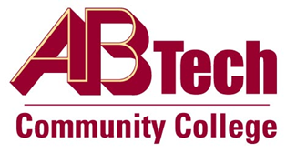

Asheville-Buncombe Technical Community College (A-B Tech) Policy Manual

Policy 509.01: Discipline
Asheville-Buncombe Technical Community College establishes and maintains a work environment that supports the students, the values, vision and mission of the institution with a goal of enforcing the policies and procedures in a fair and consistent manner. This policy permits the following types of discipline: informal counseling, performance counseling, probation, and suspension with or without pay, demotion and dismissal.

Scope
Applies to all employees of the College.

Definitions
Policies and procedures: College, state and federal policies, procedures, rules and regulations.
Informal Counseling: Oral discussion between the employee and supervisor and noted on the employee’s Performance Improvement Plan.
Performance Counseling: Oral discussion between the employee and supervisor that is acknowledged by the employee, documented, and placed in the employee’s personnel file.
Probation: The process or period of testing or observing the character or abilities of the employee.
Suspension with or without pay: A temporary cessation from work, with or without pay, depending on the identified issue.
Demotion: Reduction in employment rank or status.
Dismissal: A discharge of an individual from employment.

References
Reviewed by the Executive Leadership Team, October 26, 2011
Reviewed by the College Attorney, December 1, 2011
Policy 509.02 Employee Due Process

Policy Owner
Vice President, Human Resources & Organizational Development, Ext. 7178

See Discipline Procedure

Approved by the Board of Trustees on February 6, 2012.

