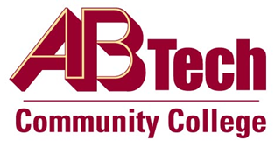

Asheville-Buncombe Technical Community College (A-B Tech) Policy Manual

Policy 306: Tobacco Free Campus
It is the policy of the Board of Trustees that Asheville-Buncombe Technical Community College provide students and employees with a safe and healthy environment.
No form of tobacco, e-cigarette, or vaporizing device usage is permitted on A-B Tech’s campuses, sites, or at College-affiliated activities and events

Scope
Applies to the A-B Tech Asheville campus and the A-B Tech sites at Enka, A-B Tech South and Madison County. This policy also applies to off-campus activities sponsored by the College.

Definitions
Tobacco Free: No forms of tobacco or e-cigarettes are permitted.
Vaporizer: A personal inhalation device.

References
Reviewed by the Executive Leadership Team, November 7 and 14, 2012, February 5, 2014, and February 3, 2016
Reviewed by the College Attorney, February 7, 2014 and February 5, 2016

Policy Owner
Vice President for Business & Finance/CFO, Ext. 7111

Approved by the Board of Trustees March 7, 2016.

