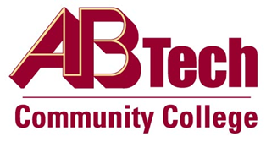

Asheville-Buncombe Technical Community College (A-B Tech) Policy Manual

Policy 1001: Web and E-Learning Accessibility
It is the policy of the Board of Trustees to provide equal opportunity to its educational services, programs, and activities in accordance with federal and state laws. This policy requires equal access to official A-B Tech web content.
This Regulation will be implemented in accordance with Section 504 of the Rehabilitation Act, the Americans with Disabilities Act, and North Carolina State Senate Bill 866; and via recommendations for proposed rulemaking from 81 Federal Regulation 28657.

Scope
All employees of A-B Tech Community College who use web content to conduct core College business or academic activities.

Definitions
Web content: Any electronically delivered information, experience, or electronic system that is communicated to the user by a web browser or other software. This includes, but is not limited to, web pages, web-based services, software applications, and embedded systems.

References
Policy 501.02, Equal Opportunity and Non-Discrimination in the Workplace
Policy 501.04, Diversity and Inclusion
NC § 168A-7, 29 U.S.C. § 701, 29 U.S.C. §794d, and 81 FR 28657 (SANPRM)
Reviewed by the Executive Leadership Team, August 17, 2016
Reviewed by the College Attorney, August 22, 2016

Policy Owner
Vice President, Information Technology, Ext. 7929

See Web and E-Learning Accessibility Procedure
Approved by the Board of Trustees on September 19, 2016.

