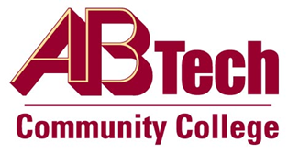

Asheville-Buncombe Technical Community College (A-B Tech) Policy Manual

Policy 1003: Acceptable Use
It is the policy of the Board of Trustees that the Information Technology resources must be treated and managed as valuable assets. The Board of Trustees hereby delegate all authority to the President to:
- Establish minimum appropriate and acceptable requirements regarding the use of information resources connected to the College Network.
- Comply with applicable state law and other rules and regulations regarding the management of information resources, including the North Carolina IT Acceptable Use Policy.
- Educate individuals who may use information resources with respect to their responsibilities associated with computer resource use.
- Establish a process to ensure that users acknowledge and agree to abide by the rules of behavior before gaining access to information resources connected to the College Network.

Scope
This policy applies to all faculty, staff, students, and guests who use A-B Tech’s Information Technology resources and/or the College Network.

Definitions
College Network: Refers to any connectivity designed for the purpose of providing Internet Protocol transport of information for A-B Tech.

References
This policy applies to state agencies, departments and other entities not specifically excluded from Article 15 of N.C. General Statute Chapter 143B, and the North Carolina Acceptable Use Policy.
Approved by the Executive Leadership Team on March 24, 2021 and July 21, 2021
Approved by the College Attorney on July 29, 2021

Policy Owner
Vice President of Information Technology/Chief Information Officer, Ext. 7929
Approved by the Board of Trustees on August 30, 2021

