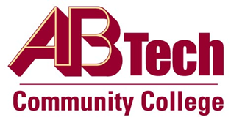

Asheville-Buncombe Technical Community College (A-B Tech) Policy Manual

Policy 207.06: Accessibility Audit of Curriculum Courses
It is the policy of the Board of Trustees that curriculum courses will be audited for accessibility in the fall and spring semesters.

Scope
All curriculum courses regardless of delivery method will be audited.

Definitions
Accessibility: Meets the current federal regulations for making content accessible to a wide range of people with disabilities.
Delivery Method: The delivery method for a class falls into one of four modes: traditional (face-to-face), online (100 percent online), hybrid (50 percent-99 percent online), or blended (less than 50 percent online).

References
Procedure 207.01, Accessibility Audit of Curriculum Courses
Section 508 of the American with Disabilities Act
Approved by the Executive Leadership Team, October 23, 2019
Approved by the College Attorney on November 25, 2019

Policy Owner
Vice President Instructional Services, Ext. 7633

Approved by the Board of Trustees on December 2, 2019

