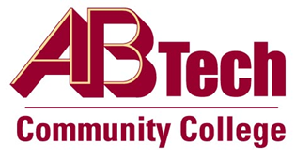

Asheville-Buncombe Technical Community College (A-B Tech) Policy Manual

Policy 503.041: Administrative Employees Work Hours
It is the policy of the Board of Trustees that the work hours and days of operations for each department of the College be based upon the area of service or function and be designed to meet the needs of our students and our community.
In order to meet the needs of our students and our community, specific hours and days of operation are established for each division and department of the College based upon the area of service and function. In the event that an office or area of the College operates outside of the typical work day, flexible schedules will be established by the supervisor, with appropriate approvals, and will be designed to serve the needs of the College.
Full-time regular staff employees are expected to work a minimum of 40 hours per week unless on an approved leave or otherwise approved by the President.
Part-time regular staff employees may work up to 29 hours per week, not to exceed 129 hours per month.

Scope
Applies to employees who are classified as executive, administrative, and managerial; professional (non-faculty); clerical and secretarial; technical and paraprofessional; skilled crafts; and service maintenance.

Definitions
None

References
Policy 503.05, Employment Categories and Classifications
Fair Labor Standards Act Section 13(a)(1); 13(a)(17)
29 U.S.C. 213(a)(1)
29 C.F.R. 541.204
Reviewed by the Executive Leadership Team, January 19, 2011, March 8, 2017, and September 20, 2018.
Reviewed by the College Attorney, March 2, 2015, March 29, 2017, and September 26, 2018.

Policy Owner
Vice President, Human Resources and Organizational Development, Ext. 7178

See Administrative Employees Work Hours Procedure

Approved by the Board of Trustees on April 1, 2019.

