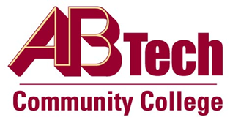

Asheville-Buncombe Technical Community College (A-B Tech) Policy Manual

Policy 709: Advertising
It is the policy of the Board of Trustees that Asheville-Buncombe Technical Community College may accept advertising that is consistent with the College’s mission, vision and values and that enhances the access to and quality of education and training by providing additional sources of revenue for the College and/or opportunities for its students.

Scope
The scope of this policy covers advertisements in A-B Tech publications and College electronic media including digital signage, broadcast on Channel 16, broadcast to the Internet, and ads on online streaming videos. The policy covers all advertising including the following:
- Advertising in College publications.
- Advertising on College web pages, in social media, College videos, email, and any other digital media controlled by the College.
- Advertising by charities or for charitable causes.
- Sampling, giveaways and other promotions.
- Use of the College internal mail, voicemail, intranet and email for non-college advertising and promotions.

Definitions
The term advertising encompasses any materials or electronic medium or part thereof used to promote an organization, product, service, idea or event.

References
Reviewed by the Executive Leadership Team, December 14 & 22, 2011
Reviewed by the Board of Trustees Executive Committee, December 15, 2011
Reviewed by the College Attorney, January 6, 2012

Policy Owner
President’s Office, Director of Community Relations & Marketing, Ext. 7117
Approved by the Board of Trustees on February 7, 2012.

