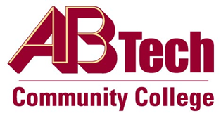

Asheville-Buncombe Technical Community College (A-B Tech) Policy Manual

Policy 319: Appropriate Use of College Resources
It is the policy of the Board of Trustees to expect all College employees, students, volunteers, interns and visitors to use College resources lawfully, ethically and with a sense of stewardship. The use of College resources is intended for College business only.

Scope
Applies to all A-B Tech employees, students, volunteers, interns and visitors.

Definitions
College Resources: This includes all College property and possessions such as telephones, computers, mobile devices, vehicles, facilities and furniture.

References
Reviewed by the Executive Leadership Team, September 26, 2012
Reviewed by the Board of Trustees Executive Committee, October 18, 2012

Policy Owner
Vice President for Business and Finance/CFO, Ext.7111

See Use of Non-Classroom Spaces for Instructional Display Procedure

Approved by the Board of Trustees on November 5, 2012.

