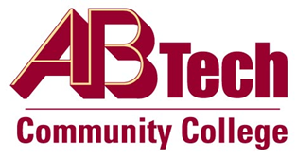

Asheville-Buncombe Technical Community College (A-B Tech) Policy Manual

Policy 203: Assignment of Course Level and Credit
It is the policy of the Board of Trustees that A-B Tech will adhere to the North Carolina Community College System Board Code regarding the assignment of course level and credit regardless of format or delivery method. It is the responsibility of faculty, academic administration, and the president to evaluate the appropriateness of course levels and credit and submit recommendations for changes to the North Carolina Community College System as appropriate.

Scope
All curriculum courses offered at A-B Tech.

References
Approved by the Executive Leadership Team on May 26, 2020, and June 14, 2023
Approved by the College Attorney on May 26, 2020
Chapter D State Board of Community College Code ( 1D SBCCC 400.1 and 400.8)

Policy Owner
Vice President of Instructional Services, Ext. 7633
See Course Level and Credit Procedure
Approved by the Board of Trustees on August 7, 2023

