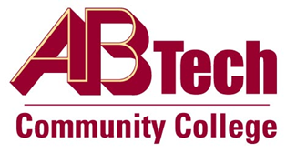

Asheville-Buncombe Technical Community College (A-B Tech) Policy Manual

Policy 820: Awarding of Curriculum Credit
It is the policy of the Board of Trustees to award curriculum credit for college-level work completed at other post-secondary institutions accredited by a regional accrediting agency as defined by the American Council on Education as long as the work has been completed with a grade of “C” or higher. A-B Tech will also consider transfer credit from non-regionally accredited institutions of higher education for only career and technical courses if the institution is accredited by an organization recognized by the Council for Higher Education Accreditation. Curriculum credit may also be awarded based upon proficiency testing or other academic analyses of competencies.

Scope
Applies to all curriculum students seeking to bring college-level work with them from another accredited college or university, from equivalency testing programs or experiential learning.

Definitions
Post-secondary institution: Any institution providing education and training beyond the high school level.
Accredited: Successful attainment of standards commonly applied to the quality of educational and administrative services of a post-secondary institution.

References
Reviewed by Academic Affairs, March 20, 2012 and October 18, 2016
Reviewed by the Executive Leadership Team, March 7 and 21, 2012, November 9, 2016

Policy Owner
Vice President for Student Services, Ext. 7146

See Awarding of Curriculum Credit Procedure

Approved by the Board of Trustees on December 12, 2016.

