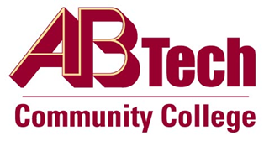

Asheville-Buncombe Technical Community College (A-B Tech) Policy Manual

Policy 415: Bookstore Operations
It is the policy of the Board of Trustees to allow the operation of a College Bookstore.
Mark-up of new curriculum textbooks sold in the college bookstore shall not exceed twenty-five percent (25%) of the cost. The bookstore may also engage in the purchase and resale of used textbooks. Pricing for used textbooks, trade books, and other merchandise will be determined by competitive market rate conditions.
In accord with 1H SBCCC 300.3 Bookstore and Bookstore Commissions, every four years the Board of Trustees shall review the College’s mark-up. Also, the profits generated by the Bookstore can only be used in accord with State Board Policy 1H SBCCC 300.3.

Scope
Applies to A-B Technical Community College Bookstore operations.

Definitions
None

References
State Board of Community Colleges Policy, 1H SBCCC 300.3 Bookstore and Bookstore Commissions
Reviewed by the Executive Leadership Team, March 22, 2023
Next Board Review Date: April 3, 2027

Policy Owner
Vice President for Business & Finance/CFO, Ext. 7111
See Bookstore Operations Procedure
Approved by the Board of Trustees on April 3, 2023.

