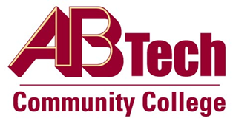

Asheville-Buncombe Technical Community College (A-B Tech) Policy Manual

Policy 901: Business Incubation Program
It is the policy of the Board of Trustees of A-B Tech Community College that the Business Incubation Program will operate in a multi-tenant facility in which new business ventures and young companies are helped to grow and succeed through their first two years, with possibility of two one-year extensions. Business Incubation is intended to be an economic development project with an objective of creating jobs and economic wealth by assisting emerging companies.

Scope
Business incubation programs and services sponsored by A-B Tech.

Definitions
Incubating Client: A new or emerging business enterprise in the service area of the College that is in need of support and assistance from the College, and without which, the likelihood of success of the business would be greatly diminished.

References
Reviewed by Executive Leadership Team, August 6, 2014
Reviewed by the College Attorney, August 15, 2014

Owner
Vice President, Economic and Workforce Development, Ext. 7937

See Business Incubation Procedure

Approved by the Board of Trustees on September 8, 2014.

