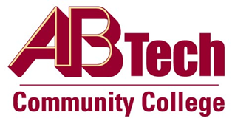

Asheville-Buncombe Technical Community College (A-B Tech) Policy Manual

Policy 301: Campus Visitors and Salespersons
It is the policy of the Board of Trustees to welcome visitors and salespersons who are identified with a specific college purpose or function. While on any A-B Tech campus or site, visitors and salespersons must comply with all A-B Tech policies and procedures.

Scope
Applies to all visitors and salespersons visiting any A-B Tech campus or site.

Definitions
Visitor: Anyone other than A-B Tech personnel, an officially enrolled student, members of the Board of Trustees, or members of a College Foundation.
Salesperson: Any person representing himself/herself, a business or organization with the intent of selling merchandise or business services on campus.

References
Reviewed by the Executive Leadership Team, March 7, 2012
Reviewed by the College Attorney, March 9, 2012
Reviewed by the Board of Trustees Executive Committee, March 15, 2012

Policy Owner
Vice President for Business & Finance/CFO, Ext. 7111

See Campus Visitors and Salespersons Procedure
Approved by the Board of Trustees on May 7, 2012.

