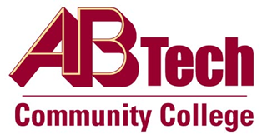

Asheville-Buncombe Technical Community College (A-B Tech) Policy Manual

Policy 320: Capital Improvement Projects
It is the policy of the Board of Trustees to adhere to North Carolina General Statute 115D-9, which provides authority to the State Board of Community Colleges regarding certain fee negotiations, contracts, and capital improvements. The State Board of Community Colleges is empowered to delegate authority to a community college under certain conditions. Capital improvements projects at Asheville-Buncombe Technical Community College will be managed in accordance with this General Statute, other applicable laws, the North Carolina Administrative Code, and the North Carolina Community College System Construction Manual. The Board may delegate specific authority to the President to execute a construction contract.

Scope
Applies to all capital improvement projects at Asheville-Buncombe Technical Community College.

Definitions
Capital Improvement: The addition of a permanent structural improvement or the restoration of some aspect of a property that will either enhance the property's overall value or increases its useful life.

References
NCGS 115D-9
Reviewed by the Executive Leadership Team, December 7, 2011
Reviewed by the College Attorney, December 8, 2011

Policy Owner
Business and Finance, Business Manager, Facilities and Operations, Ext. 7111
See Capital Improvements Projects Procedure.
Approved by the Board of Trustees on December 12, 2011.

