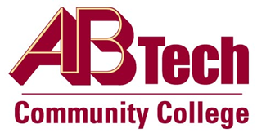

Asheville-Buncombe Technical Community College (A-B Tech) Policy Manual

Policy 804: Code of Student Conduct
It is the policy of the Board of Trustees to establish and maintain a learning environment that supports the students, the values, vision and mission of the institution. There are behavioral expectations that outline the responsibilities and proper practices for all students at the College. When the Code of Conduct is challenged, the following types of discipline include but are not limited to: verbal warning, written warning, a failing grade for an assignment or exam, probation, administrative withdrawal from a course, restitution for damages, consequences adapted to the specific violation, suspension, expulsion or actions recommended by a Threat Assessment Team.
The President shall have final approval in the expulsion of a student.

Scope
Applies to all A-B Tech students.

Definitions
Suspension: a temporary prohibition against attending the College.
Expulsion: a permanent prohibition against attending the College.
Threat Assessment Team: a team engaged by the College to:
- Assess a student’s physical, emotional and psychological well-being.
- Help the student receive the assistance he/she needs in order to continue being a productive member of the campus community.
- Maintain a safe campus environment for all.

References
Reviewed by the Executive Leadership Team, April 4 and 18, 2012
Reviewed by the College Attorney, April 17, 2012
Reviewed by the Board of Trustees Executive Committee, April 20, 2012

Policy Owner
Vice President for Student Services, Ext. 7146
See Code of Student Conduct Procedure
Approved by the Board of Trustees on May 7, 2012.

