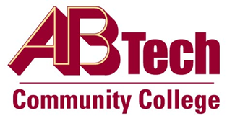

# Asheville-Buncombe Technical Community College (A-B Tech) Policy Manual

## Policy 910: Continuing Education Records Retention

It is a policy of the Board of Trustees that A-B Tech will maintain Continuing Education program related documents consistent with the North Carolina Records Retention and Disposition Schedule – Community Colleges. A-B Tech will protect the integrity and privacy of Continuing Education students and program information stored in the College Information System. All documents will be stored in paper or electronic format.

## Scope

Applies to all Continuing Education students at A-B Tech Community College.

## Definitions

Continuing Education: All non-credit programs offered at the College. North Carolina Records Retention and Disposition Schedule – Community Colleges: <http://stateschedules.ncdcr.gov>

## References

Reviewed by Executive Leadership Team, March 13, 2013

## Owner

Vice President, Economic & Workforce Development/Continuing Education, Ext. 7900

See Continuing Education Records Retention Procedure

Approved by the Board of Trustees on August 5, 2013.